I, for and on behalf of
King Air Logistics Company Limited
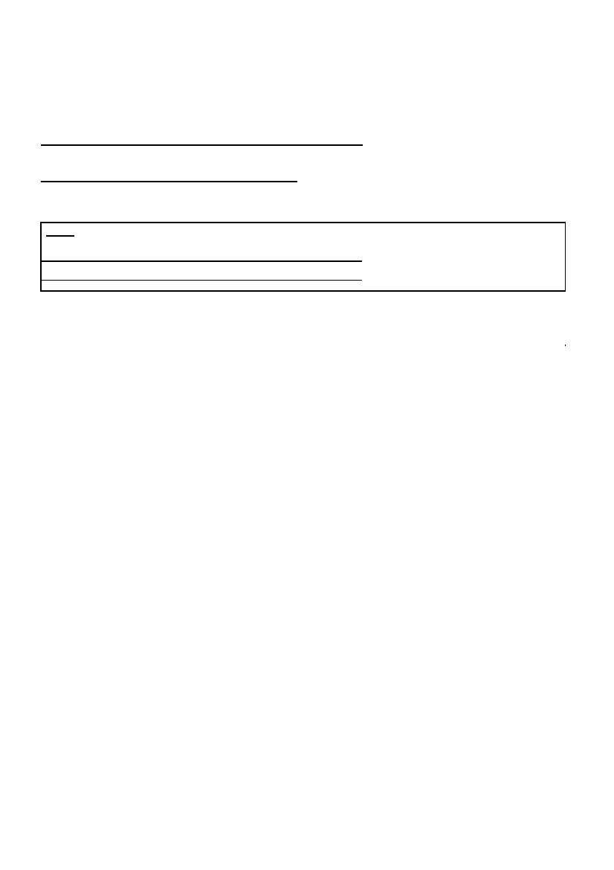(pls add your company head here)
Known Consignor
Declaration of Compliance
(company name of consignor)
(number of business registration document issued by the government
of the country with which the consignor company is registered)
(hereafter referred to as “the company”) hereby declare to%:- (% Either Part I or Part II is to be completed.)
Part I
*******
King Air Logistics Company Limited
(company name of the regulated agent who receives
cargo consignment from my company)
(RA code of the above regulated agent)
that:-
(a) Consignments of air cargo are prepared in secure premises by reliable staff members.
(b) Consignments of air cargo are protected against tampering during shipment preparation, storage and
transportation for which the company is responsible.
(c) I accept that the packaging and the contents of any consignment of air cargo may be examined for
security reasons.
(d) Consignments of air cargo do not contain any explosive or incendiary device.
(e) I accept unannounced or announced inspections by CAD or its agents and agree to provide any
documents directly to CAD for the purpose of monitoring the
compliance with security requirements stipulated in the Requirement Document for Consignor, the
Handling Procedures for Regulated Agent Regime and any other directions given from time to time by
CAD.
(f) I will ensure the continual compliance with the security requirements stipulated in the Requirement
Document for Consignor and the requirements are communicated to all staff members with access to
consignment of air cargo and/or related shipping documents.
(g) I will provide the regulated agent who recognizes my status of known consignor with the relevant details
as soon as reasonably possible if:
(i) the person responsible for application and supervision of the implementation of cargo security has
changed;
(ii) changes to premises or procedures are likely to significantly impact on security;
(iii) the company ceases trading and no longer handles air cargo; or
(iv) the company no longer implements the required security controls stipulated in the Requirement
Document for Consignor.
I understand that making false declaration knowingly may be liable to prosecution and I accept
responsibility for this declaration.

全姓名(eg. Mandy Lee)
Name:
_________________
Date:
__________________________
Position in Company:
_________________
Signature:
__________________________
Company Address:
Note
_________________________________
____________
Company Chop:
1 This Declaration shall be renewed every 3 years.
2 This Declaration shall be signed by the person responsible for application and supervision of the implementation of cargo security.
3 Texts struck out in this Declaration will be reinstated when the Independent Validation for Known Consignor is effective.
HKCAD KCDC-E (March 2013)
Page 1 of 1
正確的公司名稱
商業登記號碼
職銜

公司完整的地址
公司蓋章

